Tham Hao Wei (1006936)
Assignment 2 AI Usage Declaration

1. RAG Integration Code
For the RAG pipeline, the goal was to connect the retriever, prompt and LLM so that relevant chunks from the FAISS vector store are first retrieved and then passed into the prompt as context for the model to generate an answer.
Initially I implemented the chain directly using my LLM object without any wrapper (and it worked. However after asking ChatGPT about best practices, it suggested using a wrapper so that the LLM behaves like a LangChain runnable component. The explanation was that the wrapper standardises how inputs and outputs are passed through the chain, making it easier to plug the LLM into the retriever → prompt → output pipeline.
After understanding this, I then asked ChatGPT how to implement the wrapper and connect it with the retriever and prompt template to form the full RAG chain.

2. Base Prompt and RAG Prompts
Initially I hand wrote the 2 prompts but I found the replies given to my 20 questions was not very good. I uploaded my code to ChatGPT and one of the suggestions for improvements was to change the prompt text. I’d initial just wrote a simple short prompt asking it to answer based on retrieved documents.

Chatgpt advised me to add the following:
- Define the role of the model (“You are a helpful assistant…”) as it is good practice and helps to guide tone and behaviour
- Add the different permutations (partially answerable) as it helps the model use whatever relevant information exists instead of rejecting the question entirely. Initially I had a lot of “no information available” responses and this helped to reduce it
- Separate context, question and answer to clearly separate the roles and make reasoning easier for the LLM
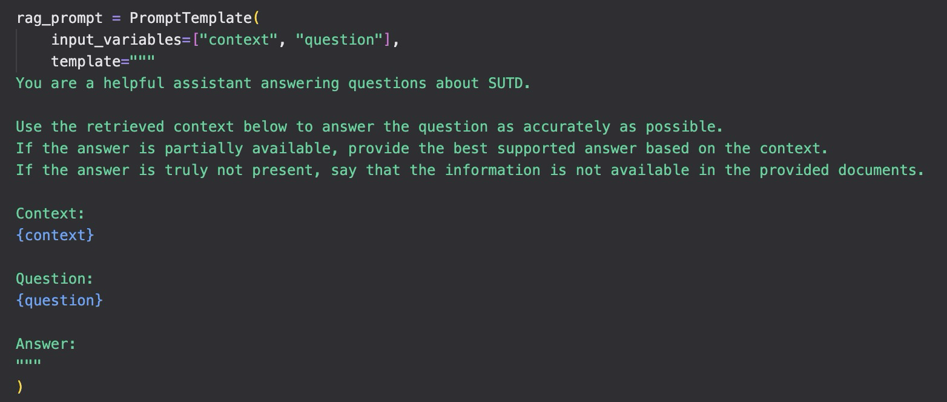

3. Chunking
For this part, I used ChatGPT mainly for the initial code scaffolding of creating the document registry and setting up RecursiveCharacterTextSplitter to chunk them for RAG.
Earlier on I was using a simpler chunking approach that split purely by characters. This caused some words and sentences to be cut in the middle, which made the chunks less readable and could potentially hurt retrieval quality. Because of that, I wanted to switch to a way that tries to split at more natural boundaries such as paragraphs or spaces. ChatGPT suggested RecursiveCharacterTextSplitter, which fits this requirement.
I also asked the AI how chunking parameters such as chunk size and overlap are typically decided, and what statistics I could print out to help judge whether my chunking setup made sense (for example document length distribution and chunk counts). Using those suggestions, I printed out page length statistics and inspected the results before deciding on the final parameters.
However, the actual chunking parameters were not taken directly from AI. I experimented with them myself. I initially tried a chunk size of 1000, but the retrieval results were not as good, so I increased it to 1200 to allow each chunk to carry more context. I kept the overlap at 150, which is roughly within the 10–20% range and helps preserve information near chunk boundaries.
